BBVA Java UI Task:
For this task, the candidate is expected to demonstrate good software design and implementation within the context of low-latency financial systems. The solution provided is expected to be of reasonable quality for a prototype. Wherever the problem is unclear, the candidate should make (and state) any assumptions he or she thinks appropriate within the application context.
The task:
Design and implement a Java Swing or JavaFX application that accomplishes the following:
1. For each of three independent price sources, the application should subscribe for continuous two-way prices for ten instruments.
2. As the two-way prices tick, the main user interface should display the latest two-way price for each price-source and instrument combination
3. Should a user double-click on any “latest” two-way price, then a dialog showing the last fifty “historic” two-way price ticks (for the price-source and instrument that the double-clicked “latest” two-way price belongs to) should be shown. The dialog should also show timestamps of every price tick and allow flexible sorting by timestamp and price.
JDK: 1.7
Design Assumptions and Guidelines:
- Client will have the facility to subscribe and un-subscribe multiple times for the same instrument
- A maximum of 50 records will be stored by the server in the data store.
- To use client server technology
- To use Google Protobuf as a protocol for fast and efficent data marshalling and unmarshalling.
- To make use of Google Protobuf Compiler based model generation
- Will work on aysnchronous RPC with call back style client mechanisms
- To use Low level socket programming and protocol
- To use for better memory handling a FIFO queue like data structure to be used. (Linked hash map with delete on excess count was used and hence memory was properly managed
- Three Different Data source price data will generated by the application using random values

Packaging:
1. Executable java jar file for client
2. Executable java jar file for server
3. Source code available from github location https://github.com/smohamedfarouk/BBVAPriceTicker
4. Java Doc available on the folder javadoc

How to start the server:
- Java command available in the class path
- Copy the files, client.jar and server.jar to any folder in C Drive
- Open 2 command windows, one for client and another for server
- Navigate to the folder where the jars are available
- First start the Pricing Server first
java - jar Server.jar
- Then start the client
java - jar Client.jar
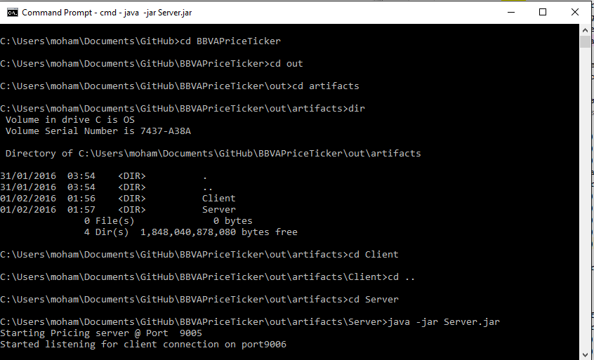
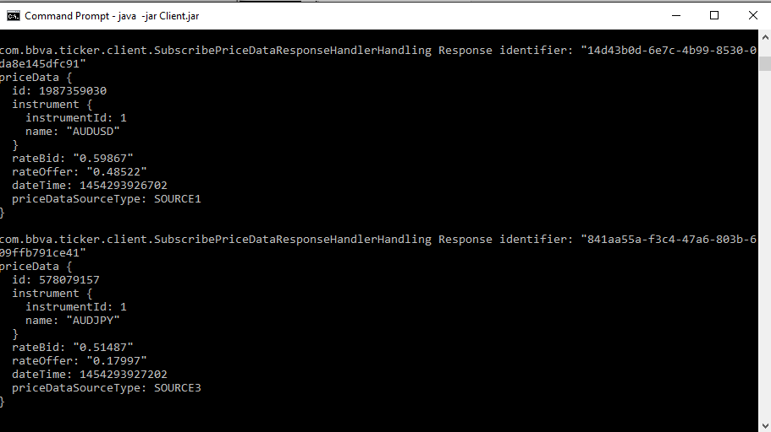

Application Screen View
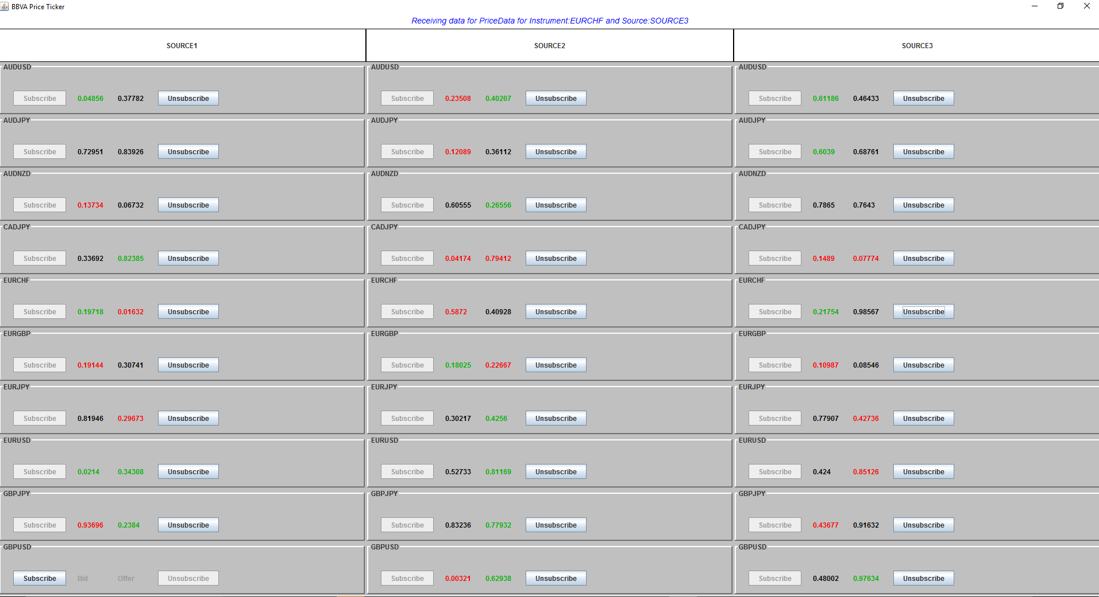

Price History View ( When either Bid or offer is double clicked)
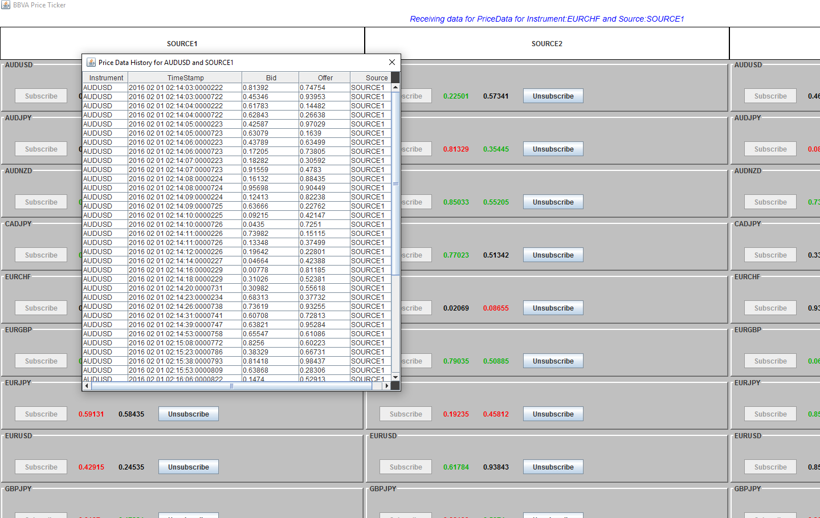

Design UMLs: Client
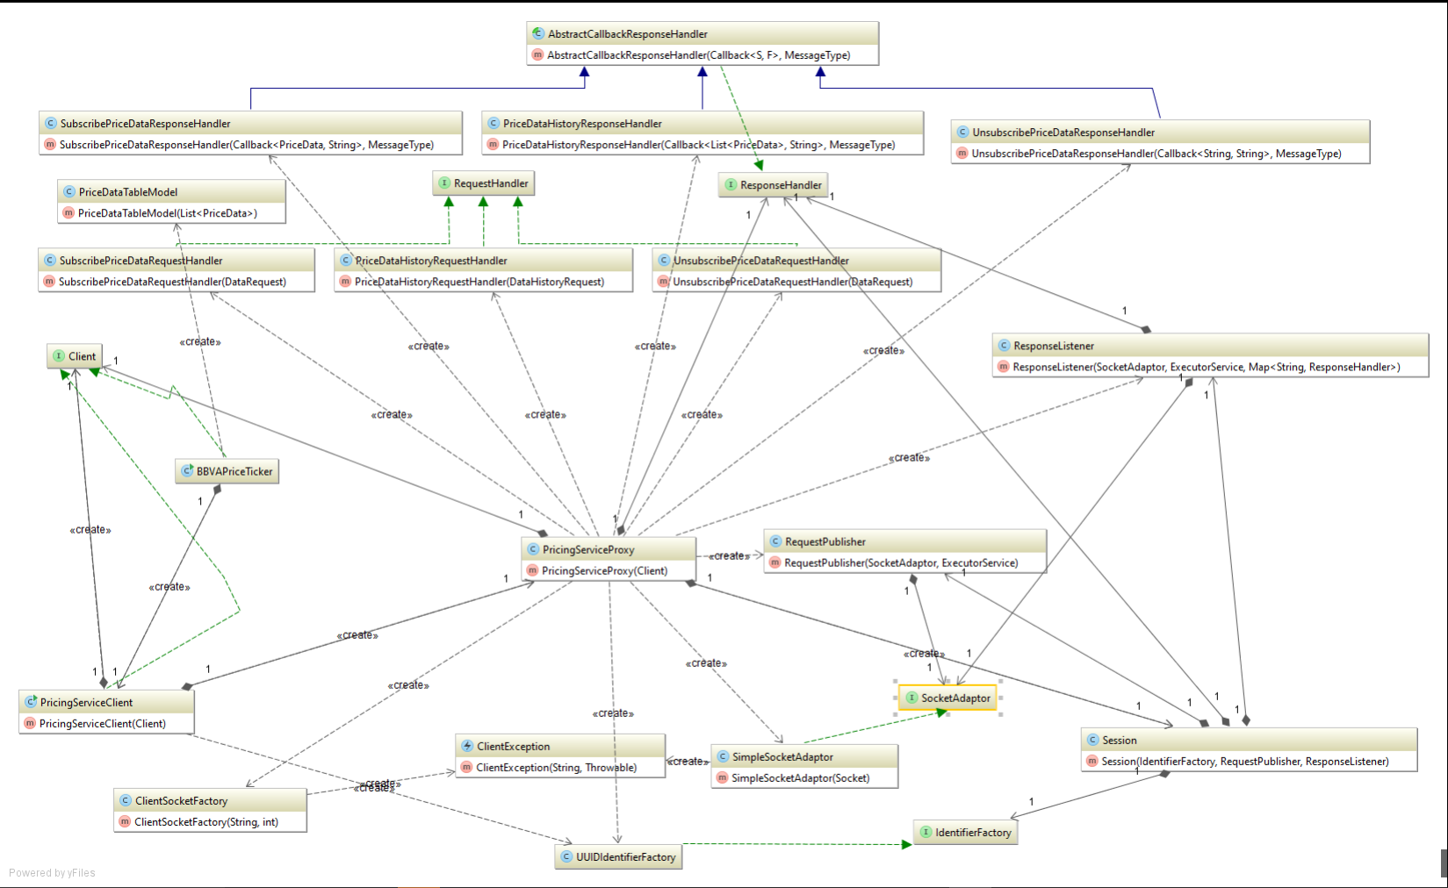

Design UML: Model (Google Protobuf generated)
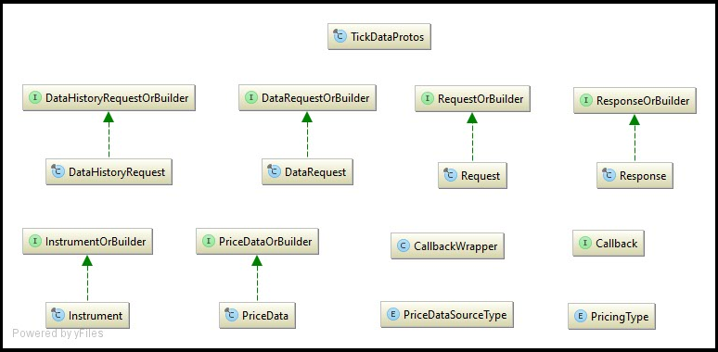

Design UML: Service Layer
